MANAGEMENT INFOTMATION SYSTEM

LAB EXPERIMENTS

RAJA SHEKHAR.K-192124197

1) Draw a UML diagram for hotel reservation system. In a hotel reservation system, a customer can make online booking for a hotel, by specifying the accommodation requirements such as type of room (AC/Non-AC, One bed/two bed), total no of rooms, duration of stay. The system selects a suitable hotel as per customer’s requirements. If a hotel is found then the availability of rooms in that hotel is checked. The charges are calculated for the selected requirement and these are acknowledged to the customer. If the customer is satisfactory about the sel ection made by the system, then he confirms the reservation.

**Aim:**

To design a **UML Class Diagram** for a **Hotel Reservation System**, which enables customers to book hotel rooms based on their accommodation requirements.

**Procedure:**

1. **Identify Key Classes:**
   * **Customer**: Represents users who book hotels.
   * **Hotel**: Represents hotels available in the system.
   * **Room**: Defines different types of rooms available.
   * **Booking**: Manages the reservation process.
   * **Payment**: Handles payment transactions.
2. **Define Attributes and Methods:**
   * **Customer**: customerID, name, contactInfo, makeReservation(), cancelReservation()
   * **Hotel**: hotelID, name, location, checkAvailability()
   * **Room**: roomID, roomType, price, availabilityStatus
   * **Booking**: bookingID, customerID, hotelID, roomID, checkInDate, checkOutDate, confirmBooking(), calculateCharges()
   * **Payment**: paymentID, amount, paymentMethod, processPayment()
3. **Establish Relationships:**
   * A **Customer** can make multiple **Bookings**.
   * A **Booking** is linked to one **Hotel** and one or more **Rooms**.
   * A **Room** belongs to a **Hotel**.
   * A **Payment** is linked to a **Booking**.

**Output:**

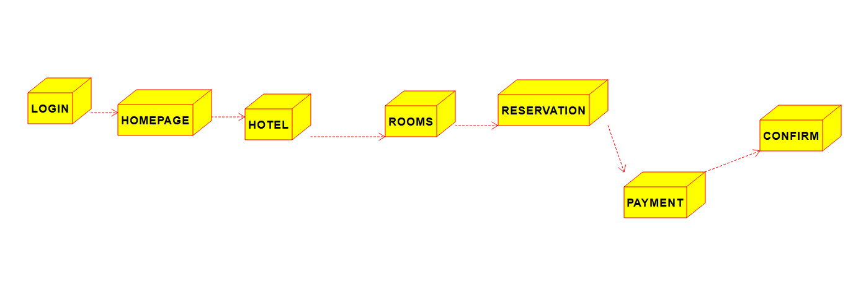

1. **Deployment diagram**

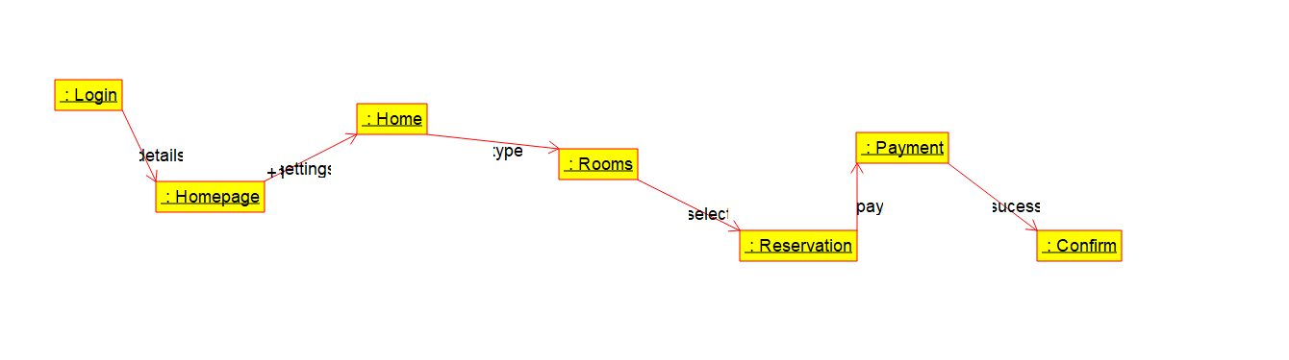

**2 . communication diagram**

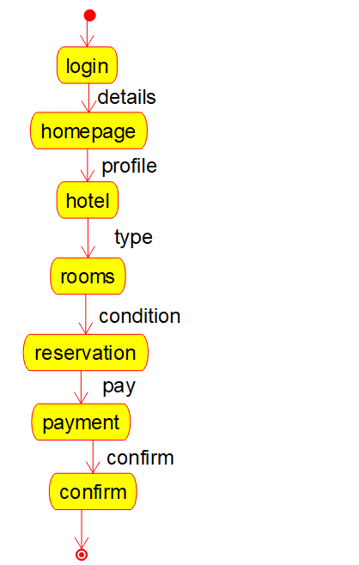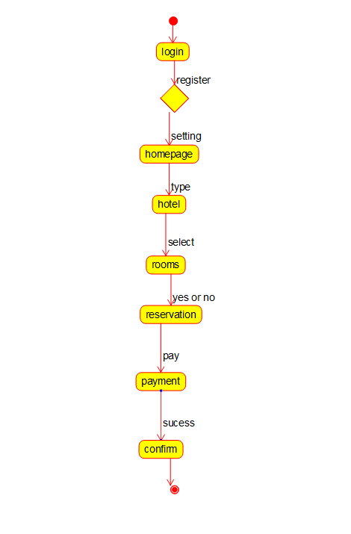

**Activity diagram State diagram**

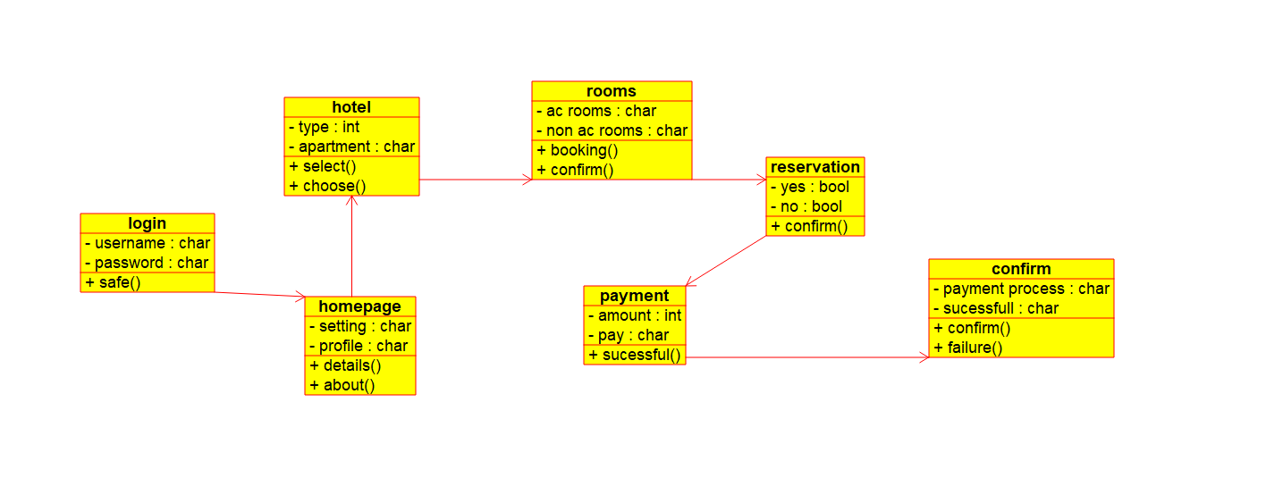

**Class diagram**

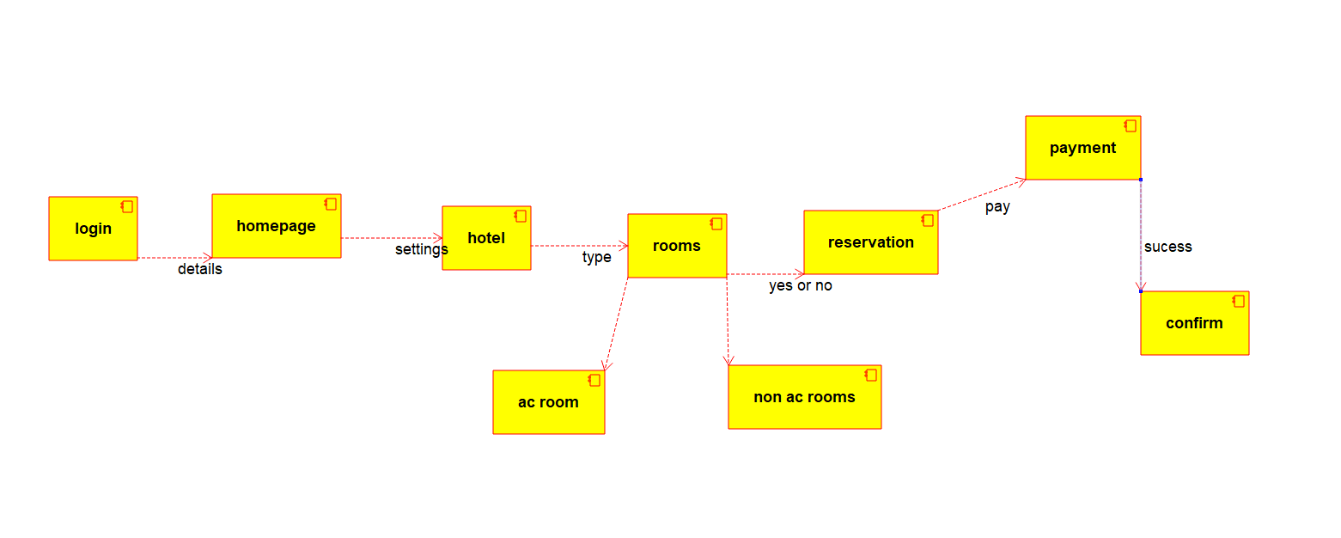

**Component diagram**

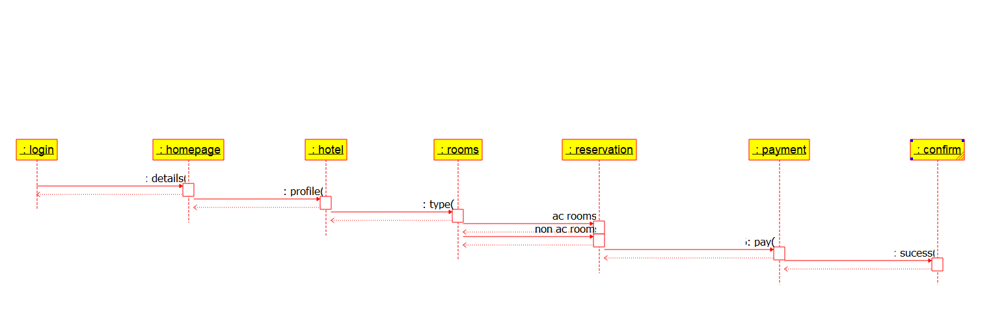

**Sequence diagram**

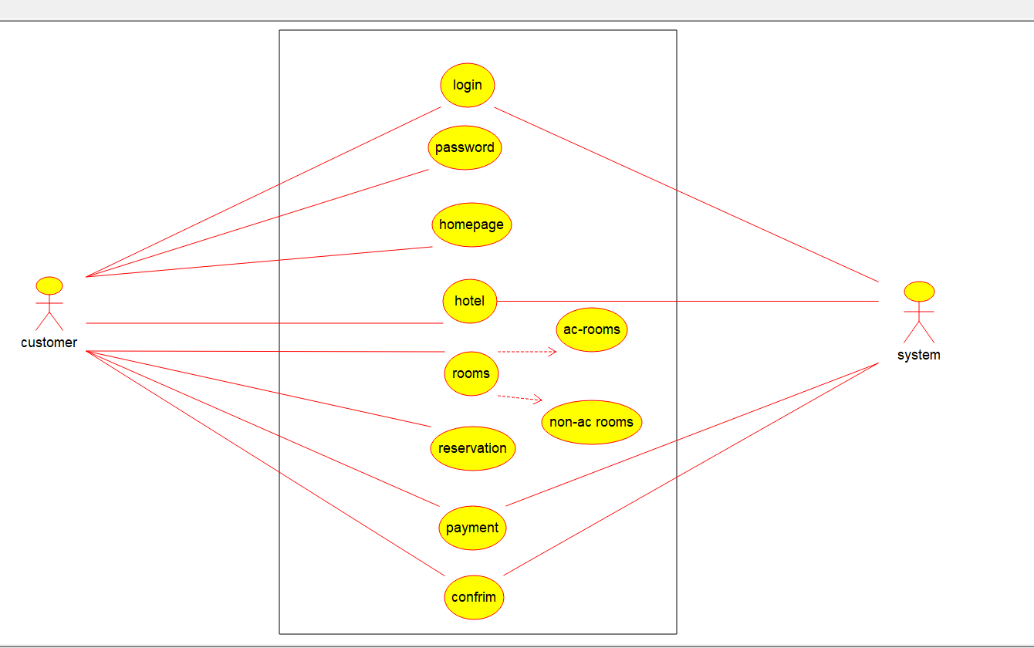

**Use case diagram**

**Result:**

A UML Class Diagram will be created based on the above design.